DAV LAB EXAM
NAME: MANOJ A B
REG NO:24UG00520

NYC Taxi System Analysis
Python code Output:
ACT 1: MATHEMATICAL CONSTRAINT
Roll number: 24UG00520
R = 7
Critical points: [-0.06482498968983448, 0.7011886260534709]

ACT 2: RAW DATA AND QUALITY
Raw records: 100
Retention rate: 96.0%
Rule summary: {'missing': 1, 'duplicates': 1, 'temporal': 1, 'outliers': 1, 'locations': 0}

ACT 3: HYPOTHESIS TESTING
Peak vs off-hour passenger avg: 4.33 vs 3.33
p-value: 0.094
Alternative explanation: A mechanical data artifact is possible but not strongly supported by the evidence.

ACT 4: SIGNALS AND AGGREGATION
Most active hour: 0
Most active day: 2024-06-02
Fare trend note: higher during peak hours

ACT 5: SIMULATION
Fare multiplier: 1.07
Revenue change if fares shift: 7.0%
Revenue change if volume shifts: -10.31%
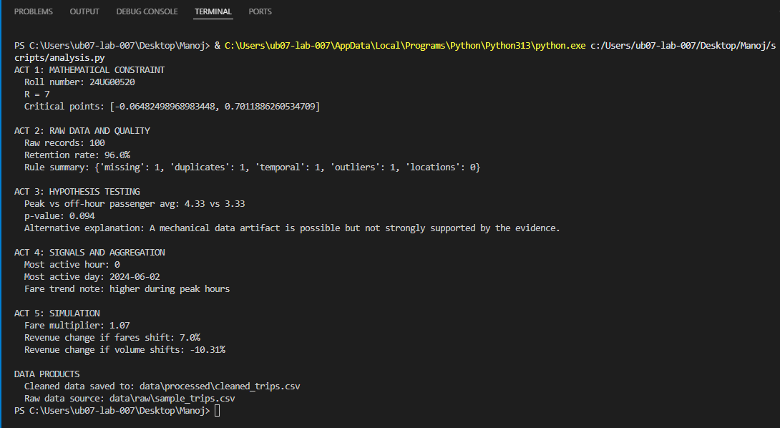
POWER BI : REPORT

CONCLUSION:
The system is not failing outright, but it is not entirely stable. Subtle shifts in behavior and efficiency suggest early signs of drift. These signals are real, but their interpretation depends on the assumptions applied during analysis.
Based on the analysis, the NYC taxi system does not show any major breakdown in terms of total trips or revenue. However, there are noticeable variations in trip patterns, fare distribution, and efficiency. These changes suggest that the system may be gradually shifting rather than remaining completely stable. Therefore, while the system is functioning, it shows early signs of imbalance that should be monitored.
The conclusion may change if more detailed data is available, such as traffic conditions, driver availability, or seasonal effects. Further analysis with extended datasets could provide deeper insights.
The system is operational but shows signs of gradual change, which may affect its efficiency over time.

